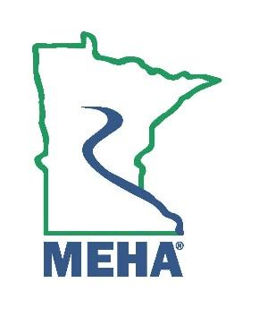
MINNESOTA ENVIRONMENTAL HEALTH ASSOCIATION

Emerging Professional Award Nomination Form

This award is to give recognition to the Environmental Health (EH) professional who:
a. Actively participates in MEHA activities, is a member in good standing of MEHA, with not more than seven years of experience in Environmental Health who:
b. Has provided exceptional contributions in the promotion of the Environmental Health profession, or demonstrated outstanding dedication to Environmental Health.

Nominee Name:
Address:
Employer:
Position/Title:
Phone:
Email:
How long has the nominee been an Active member of MEHA in good standing?
How many years of professional experience in EH does the nominee have?
Please attach a memo describing the nominee’s candidate contributions to the field of Environmental Health above and beyond the expected level of job performance, which also contributed to the elevation of professional status of the EH professional. Include relevant supporting documentation.

Nomination Submitted By:
Name:
Address:
Phone:
Email:

Send form to the MEHA Awards Committee by February 24th, 2025 at:
Sophia.walsh@state.mn.us

