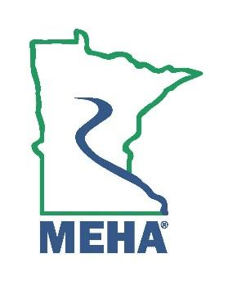
MINNESOTA ENVIRONMENTAL HEALTH ASSOCIATION

Honorary Membership Award Nomination Form

This award is to give recognition to any person who:
Has performed any distinguished achievement or service for public benefit.

Honorary membership may be conferred by a two-thirds (2/3) vote of the Board of Directors.

Nominee Name:
Address:
Employer:
Position/Title:
Phone:
Email:
How long has the nominee been an Active member of MEHA in good standing?
How many years of professional experience in EH does the nominee have?
Please attach a memo describing the accomplishments that significantly contribute to the development, expansion, or achievement of environmental health; or the service performed that has produced a positive benefit to the profession as a whole. Either of these accomplishments can be a single achievement or a continuing performance of merit. Include relevant supporting documentation.

Nomination Submitted By:
Name:
Address:
Phone:
Email:

Send form to the MEHA Awards Committee by February 24th 2025 to:
sophia.walsh@state.mn.us

