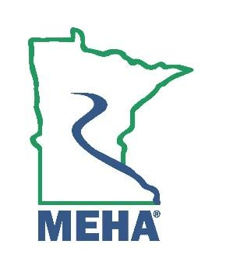
MINNESOTA ENVIRONMENTAL HEALTH ASSOCIATION

Life Membership Award Nomination Form

This award is to give recognition to any previously active member.

Life membership may be conferred by unanimous vote by the Board of Directors.

Nominee Name:
Address:
Employer:
Position/Title:
Phone:
Email:
How long has the nominee been an Active member of MEHA in good standing?
How many years of professional experience in EH does the nominee have?
Please attach a memo describing the accomplishments that significantly contribute to the development, expansion, or achievement of environmental health; or the service performed that has produced a positive benefit to the profession as a whole. Either of these accomplishments can be a single achievement or a continuing performance of merit. Include relevant supporting documentation.

Nomination Submitted By:
Name:
Address:
Phone:
Email:

Send form to the MEHA Awards Committee by February 24th 2025 to:
sophia.walsh@state.mn.us

