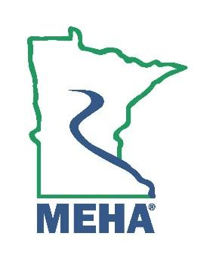
MINNESOTA ENVIRONMENTAL HEALTH ASSOCIATION

Certificate of Merit for Outstanding Service to MEHA Award Nomination Form

This award is to give recognition to the Environmental Health (EH) professional who:
- Is an individual or an organization
- Has performed outstanding service to the Association

Nominee Name:
Address:
Employer:
Position/Title:
Phone:
Email:
Please attach a memo describing the nominee’s accomplishments or service that significantly contributed to MEHA. Include relevant supporting documentation.

Nomination Submitted By:
Name:
Address:
Phone:
Email:

Send form to the MEHA Awards Committee by February 24th 2025 to:
Sophia.walsh@state.mn.us

