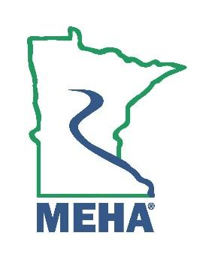
MINNESOTA ENVIRONMENTAL HEALTH ASSOCIATION

Staffenson Award Nomination Form

This award is to give recognition to the Environmental Health (EH) professional who:
a. Is a member of the Association in good standing; and
b. Is active as an administrator, supervisor, or environmental health professional, and
c. Is a Registered Environmental Health Specialist/Sanitarian in Minnesota.
d. Has been active in the field of Environmental Health for at least 10 years, and
e. Has been an active member of the Association for at least 5 years, and
f. Has contributed significantly to the development, expansion, or advancement of environmental health; or has performed a service that has produced a benefit to the profession as a whole. Either of these accomplishments can be a single achievement or a continuing performance of merit.

Nominee Name:
Address:
Employer:
Position/Title:
Phone:
Email:
How long has the nominee been an Active member of MEHA in good standing?
How many years of professional experience in EH does the nominee have?
Please attach a memo describing the nominee’s candidate contributions to the field of Environmental Health above and beyond the expected level of job performance, which also contributed to the elevation of professional status of the EH professional. Include relevant supporting documentation.

Nomination Submitted By:
Name:
Address:
Phone:
Email:

Send form to the MEHA Awards Committee by February 24th 2025 to:
Sophia.walsh@state.mn.us

